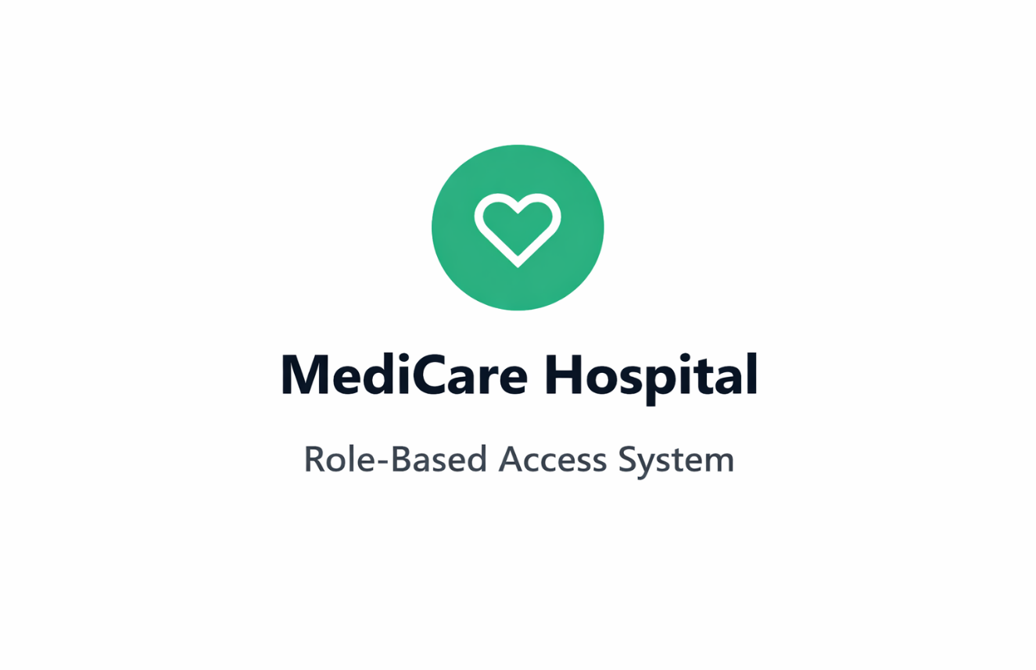
Alexandria National University
Faculty of Computers and Data Sciences
Human Security Final Project
Presented by:
Abdallah Mohammed Hejazi 2205228
Ziad Mahmoud Abdelgwad 2205021
Mohamed Hany Khattab 2205053
Amina Ahmed Ferra 2205225
Maryam Waheed Zamel 2205154
Hanin Mohamed Hamouda 2205232
Mayssoune Hussein Elmasry 2205251

1. Introduction
This project presents a fully secured Hospital Management System that focuses on digital identity management, authentication, authorization, and role-based access control (RBAC) using Keycloak.
The main goal of the project is not system complexity, but to correctly implement secure login, token-based access, role enforcement, and centralized identity management. The system follows modern security principles where authentication and authorization are fully separated from business logic.
Keycloak is used as a centralized Identity and Access Management (IAM) server to handle user identities, roles, and tokens securely.

2. System Overview
The Hospital Management System allows different users to access the system based on their roles:
- Admin: Full control over the system (CRUD operations)
- Doctor: Can create, read, and update patient records
- Patient: Can only view their own medical data
All users authenticate through Keycloak, and access to backend APIs is strictly controlled using JWT access tokens.
4. Technology Stack
- Frontend: Html, JS, CSS Tailwind
- Backend: Flask python
- Database: SQLite
- Identity and Access Management: Keycloak

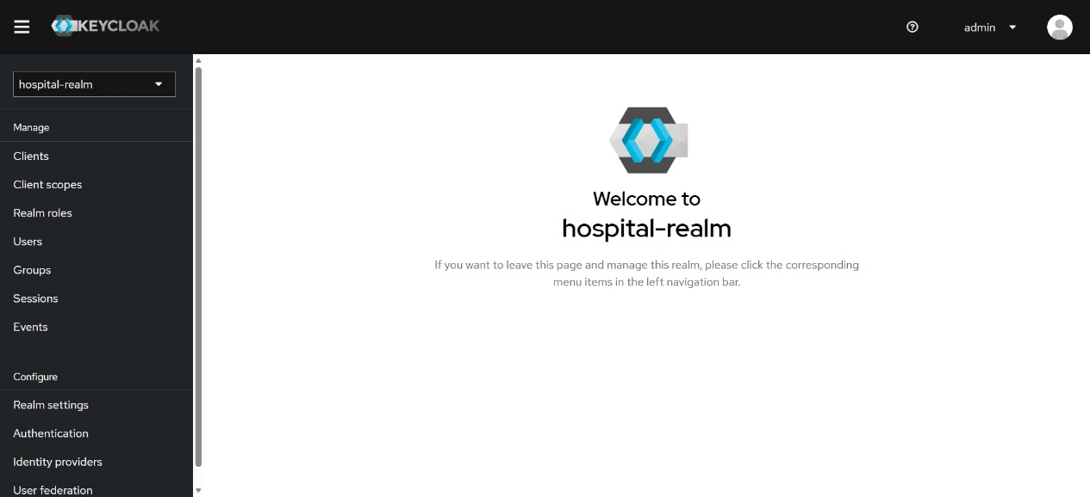
A Realm is the top-level container in Keycloak. It represents an isolated security domain.
Each realm has its own:
- Users
- Roles
- Clients
- Authentication policies
Our realm is hospital-realm , users and clients in it can not access another realm
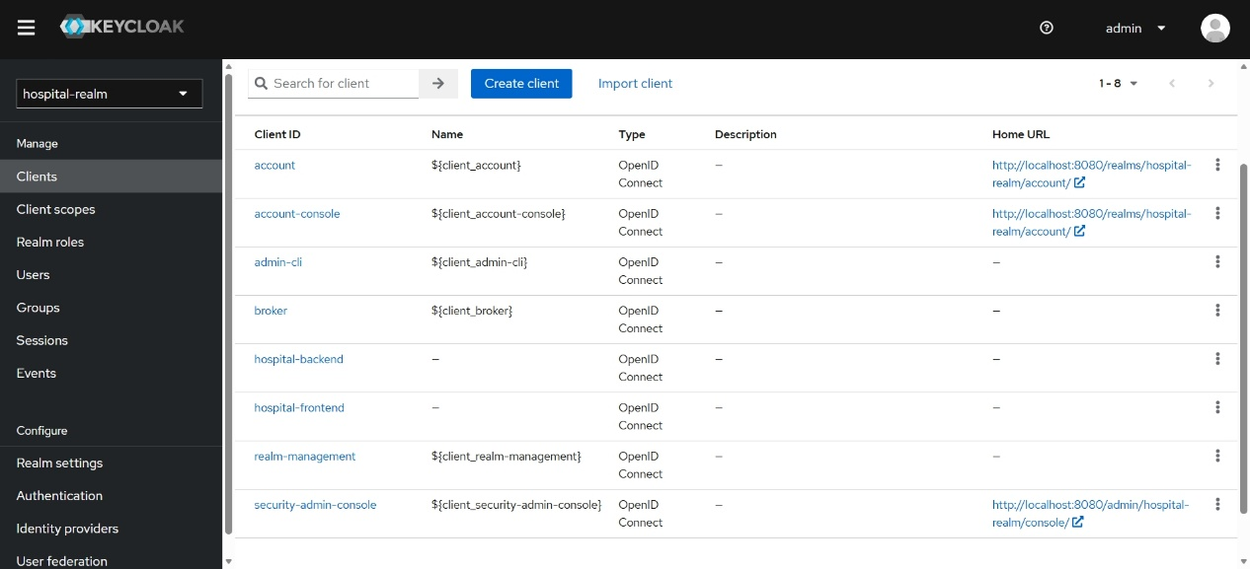
We create two clients :
Frontend Client
- Represents the UI application (React, Angular, etc.).
- No client secret stored securely.
- Handles:
  - User login
  - Redirect to Keycloak
  - Receiving access token
Backend Client
- Represents the API / server application (Flask).
- Configured as a Confidential Client.
- Uses client secret.
- Responsibilities:
  - Validate access tokens
  - Enforce role-based authorization
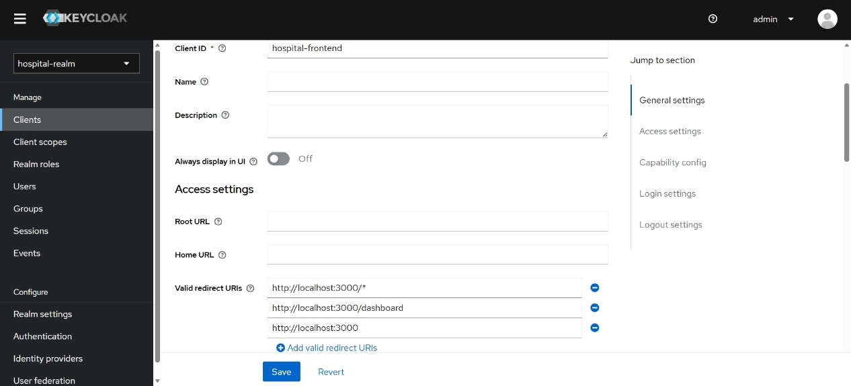
Here, redirection URLs used to tell keycloak what is the website that will redirect to. As our web runs on localhost://3000 so we write it here
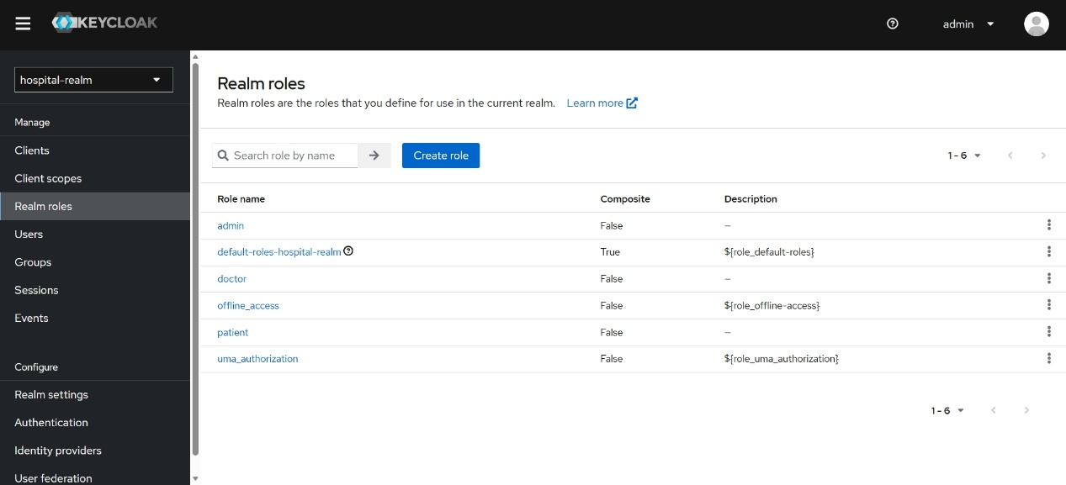
Realme roles used to generate valid roles we have to be the basis of other users as each user will have predefined role based on it will take valid privileges
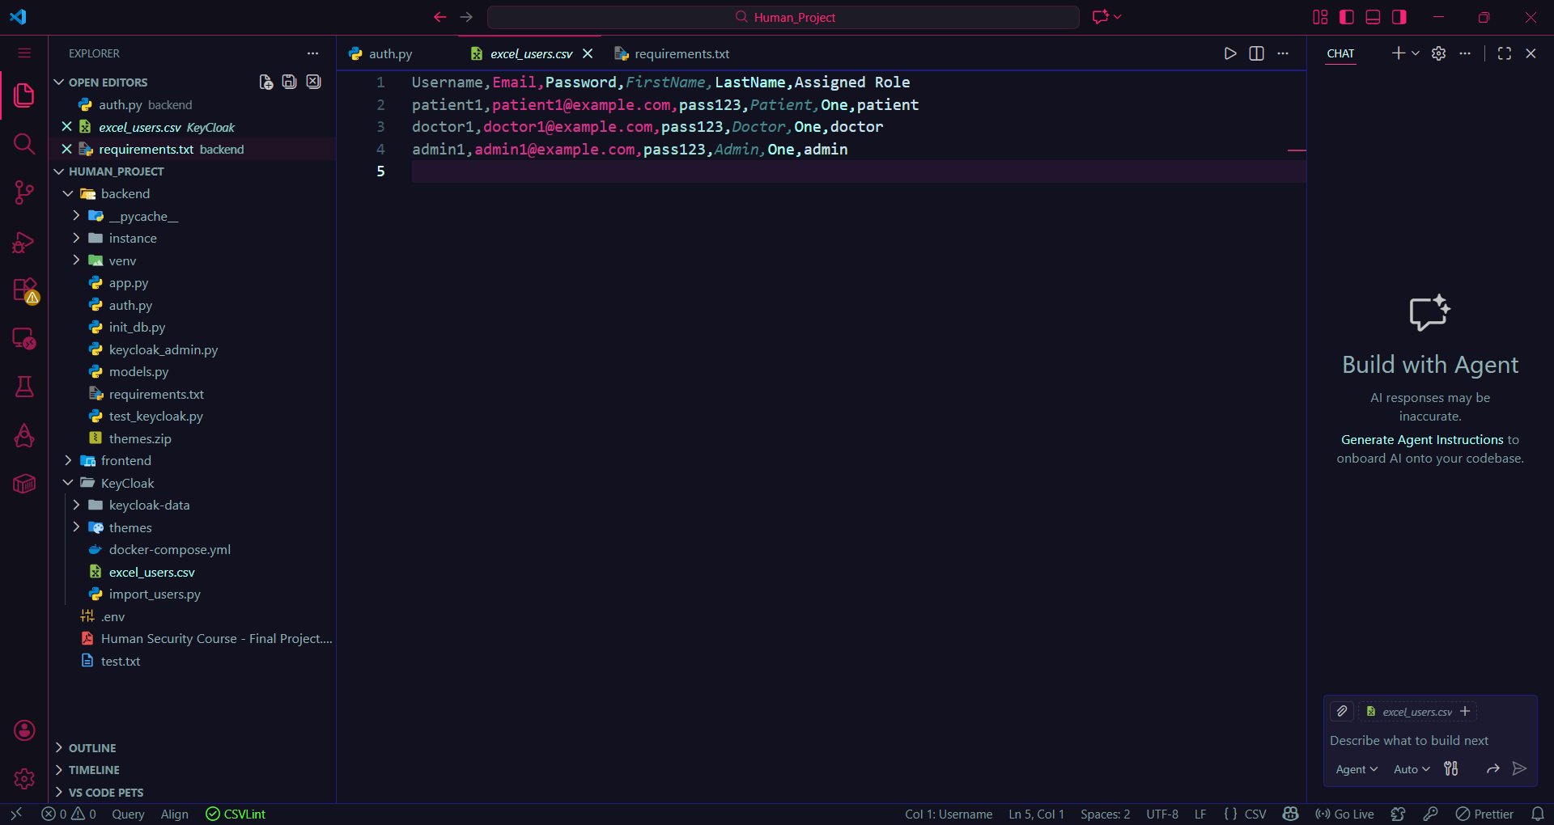
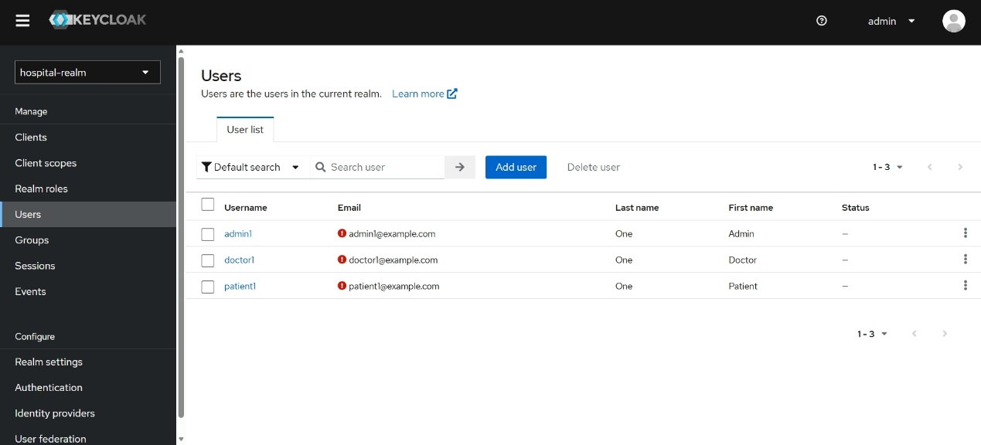
As we do not want to import users in keycloak manually, we define excel file named excel_users.csv that define attributes of each user then by writing the script import_users.py this responsible for importing users in the keycloak. As seen in keycloak users the users are imported successfully.
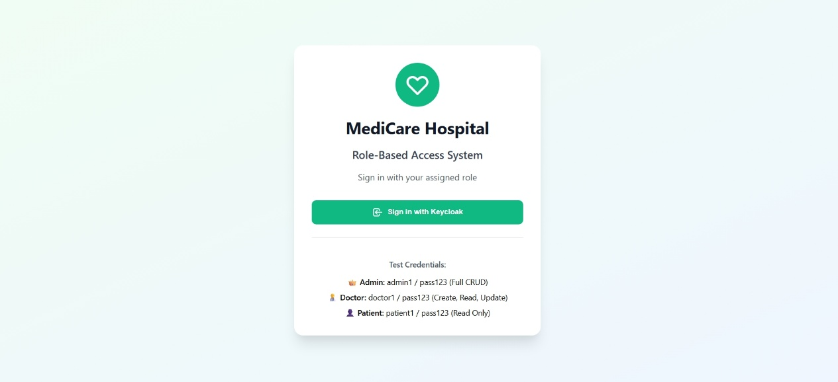
Now the project is ready to run. We run frontend, backend and keycloak in different servers so we run keycloak firstly on docker , run backend on port 5000 and when running frontend on port 3000, the login page is seen and allow us to login using keycloak only as required.
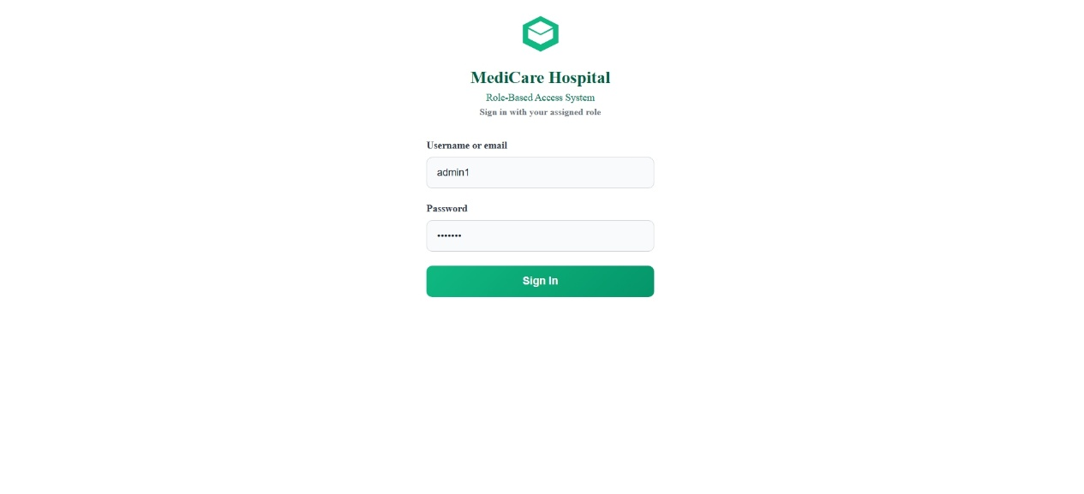
Now when pressing sign in with keycloak, it redirect to our custom login page of keycloak and this created by editing theme of keycloak and change it in the theme setting
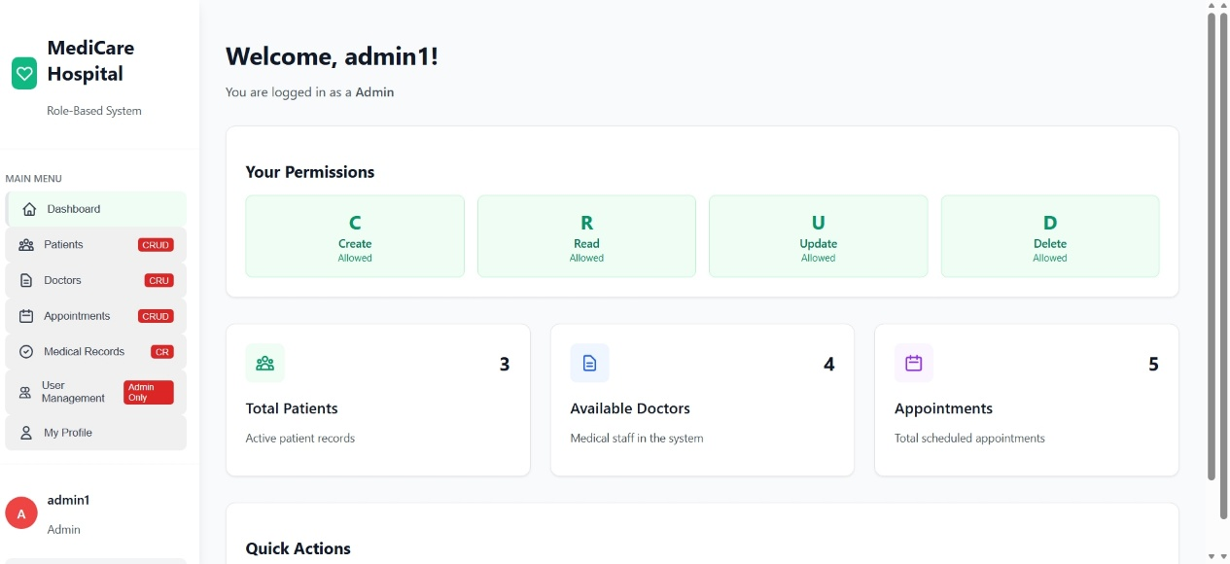
The first role we have is Admin. He have the full permissions of CRUD operations so he can create new user and this will be seen in database and keycloak, read all data of the hospital system such patients and doctor data and manage users in the system
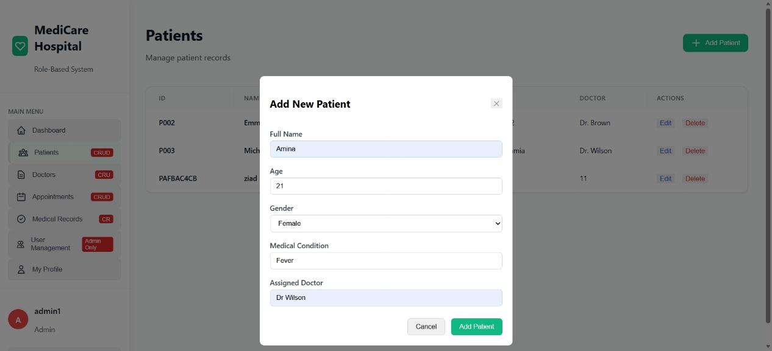
As seen here admin can add new patient by entering its credentials and this change will be added to the database and users in keycloak.

We start initially adding users by importing then using excel file then when the admin decide to add new patient for example this will be added also
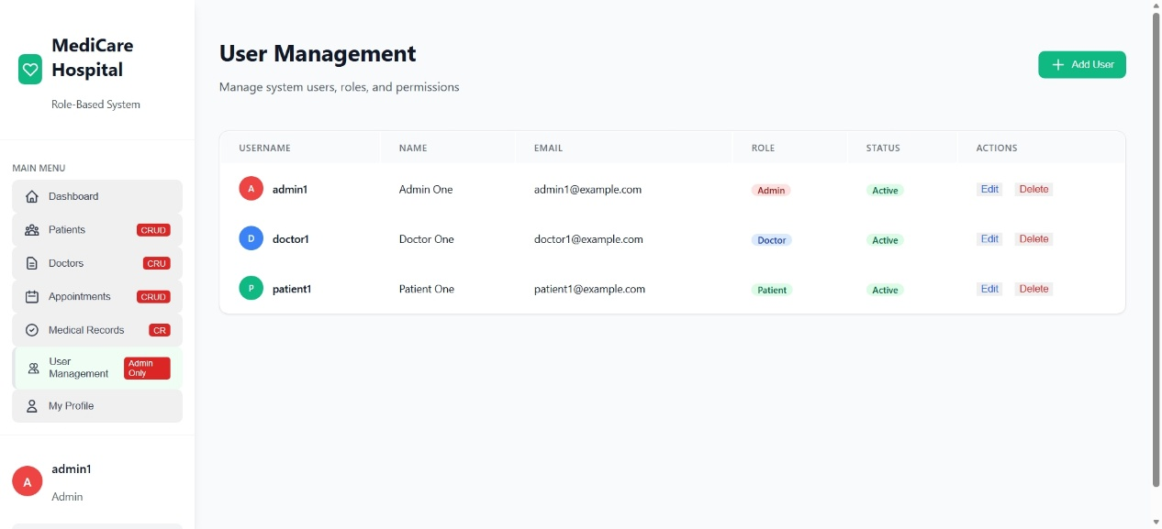
In user management , admin can edit any user with any role by changing its role or password. He can also change the status of specific user to be active or inactive. Finally deleting user is a permission allowed to admin also
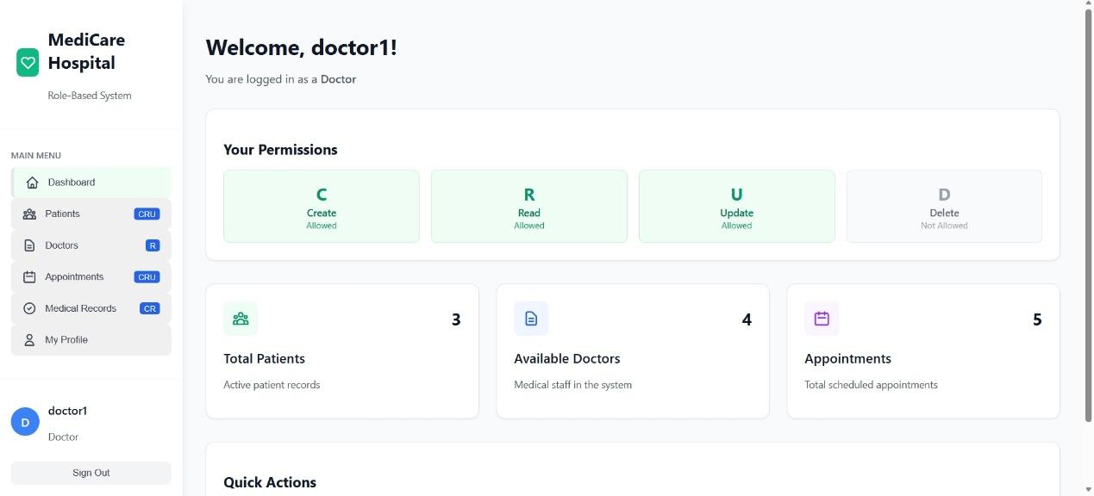
The second role is doctor. He has the same permissions such as admin except delete operation.
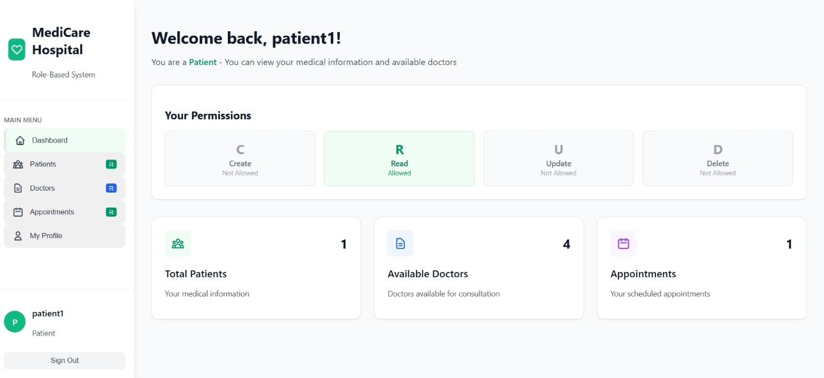
The third role is patient.
Patient only has read permission so when logging as patient this patient can see only its data such as doctor he assigned to and its appointment.
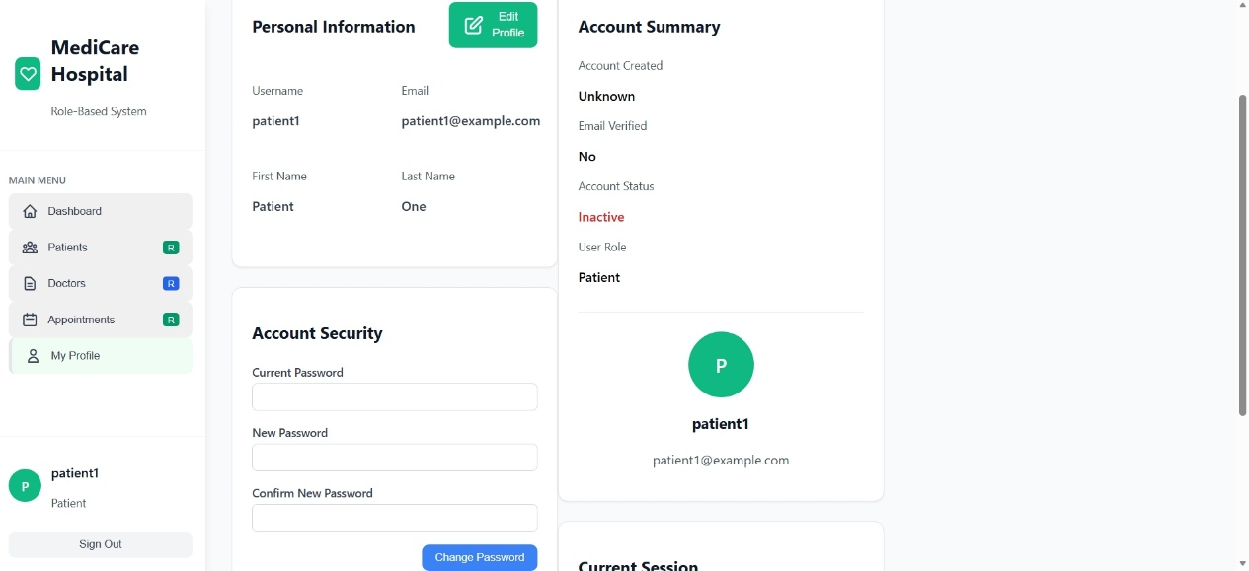
By default, each patient has default password but we add permission for them if he wants to change its password, he can go to its profile and change the password. Except this he is not allowed to do anything else

